Installation Apache,Mysql and PHP in Ubundu

sudo apt-get update

sudo apt-get install apache2

if the above command thoroughs the below error

Reading package lists... Done
Building dependency tree
Reading state information... Done
Some packages could not be installed. This may mean that you have
requested an impossible situation or if you are using the unstable
distribution that some required packages have not yet been created
or been moved out of Incoming.
The following information may help to resolve the situation:

The following packages have unmet dependencies:
apache2 : Depends: apache2-bin (= 2.4.7-1ubuntu4.4) but it is not going to be installed
E: Unable to correct problems, you have held broken packages.
Run the following commads

sudo apt-get remove libaprutil1
sudo apt-get autoremove
sudo apt-get install apache2
check to see if Apache is running by running the command:
service apache2 status
You will get the apache status as *apache is running
Open the browser and type localhost you will see the apache details as web page.
It ensures that you have installed apache2 successfully in ubuntu.
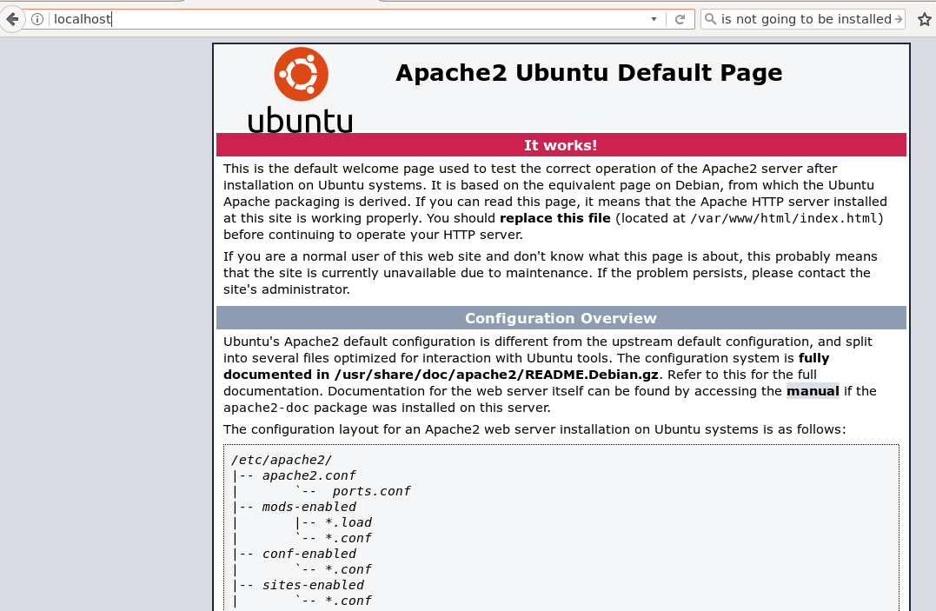

Installing MySQL on Ubuntu
sudo apt install mysql-server
During the install, it will prompt you to enter a MySQL root password. Set any password that you would like. It should be a strong password.
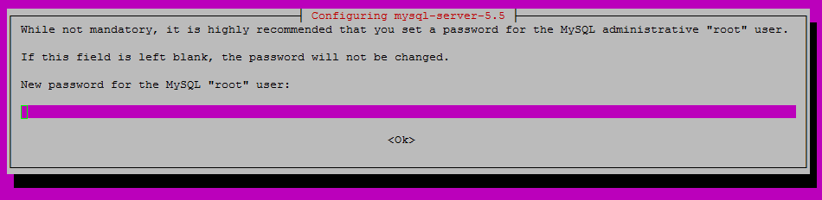
Enter a strong password of your choice
After you enter your MySQL root password, you will need to re-enter it.
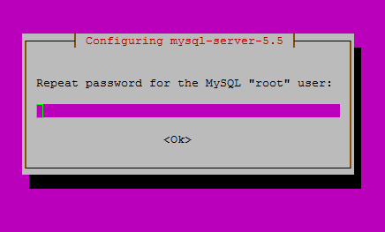
Re-enter the password you set before
mysql_secure_installation
You will be prompted with a series of questions. Just type N for the change root password and Y for yes on all of the rest, see the screen shot below
Change the root password? [Y/n] n

Remove anonymous users? [Y/n] y

Disallow root login remotely? [Y/n] y

Remove test database and access to it? [Y/n] y

Reload privilege tables now? [Y/n] y

service mysql status

Installing PHP onUbuntu

sudo apt install php5-fpm
sudo apt install libapache2-mod-php5
Restart apache server to run php in apache
service apache2 restart

Create a test PHP file called info.php in /var/www/html/. In this how-to, we will be using the text editor nano with the following command:
nano /var/www/html/info.php
<?php
phpinfo();
?>
Reference:
https://www.atlantic.net/community/howto/install-linux-apache-mysql-php-lamp-stack-on-ubuntu-16-04/

INSTALL phpMyAdmin
Once Apache, PHP and MySQL are installed, we can go ahead and install phpMyAdmin. The package is included in the official Ubuntu 16.04 repository and it can be easily installed with the command below
apt-get install phpmyadmin
phpMyAdmin will be installed along with its dependencies and all necessary PHP modules.

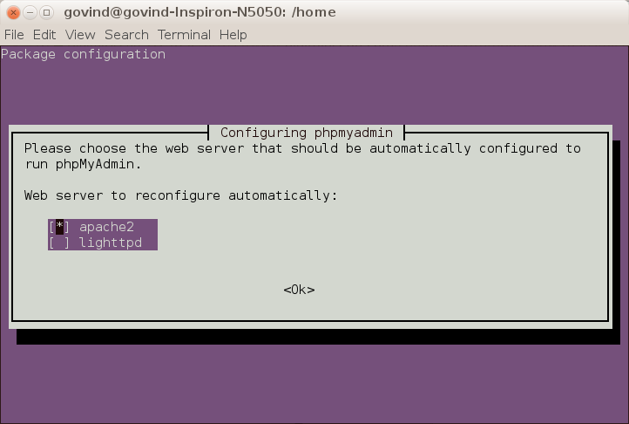
When you will be prompted to select a web server to configure, hit the space bar to select Apache2 and Enter to confirm and continue

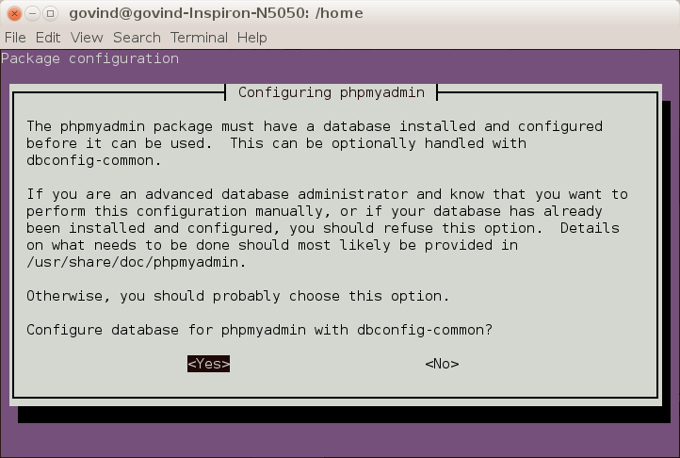
Afte enter Yes
Enter database administrative password
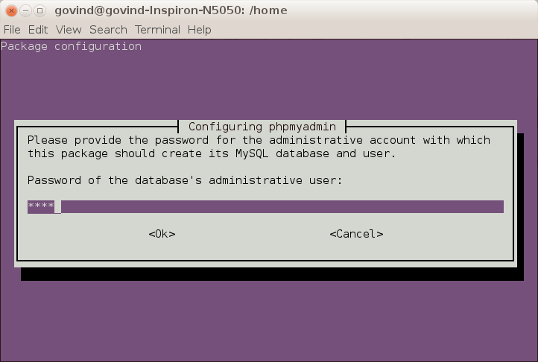

Enter phpmyadmin to register with database server
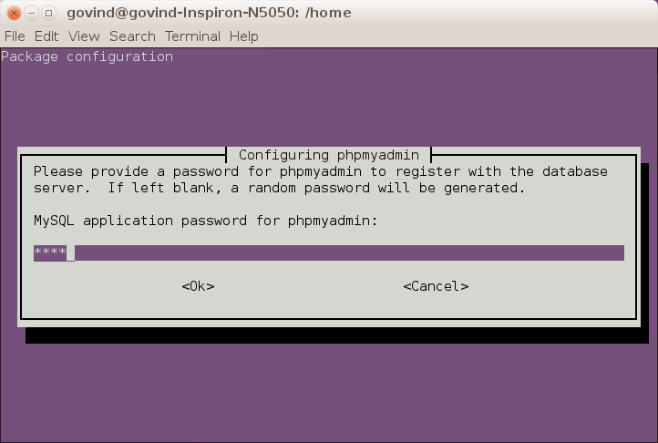
Confirm the password
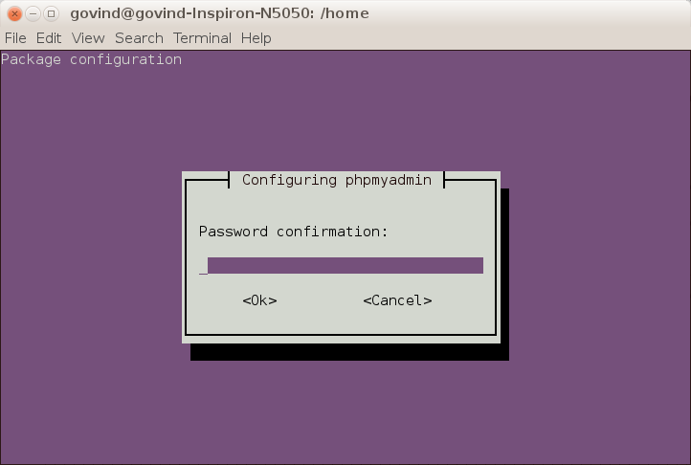
Restart the apache service and access the phpmyadmin from localhost
http://localhost/phpmyadmin/
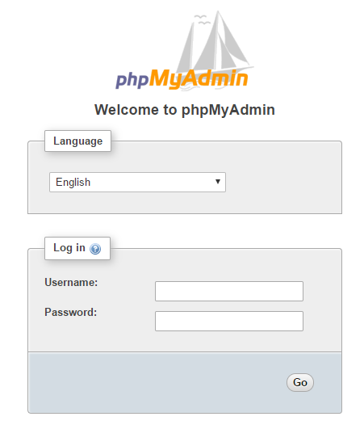

Loging using username and password

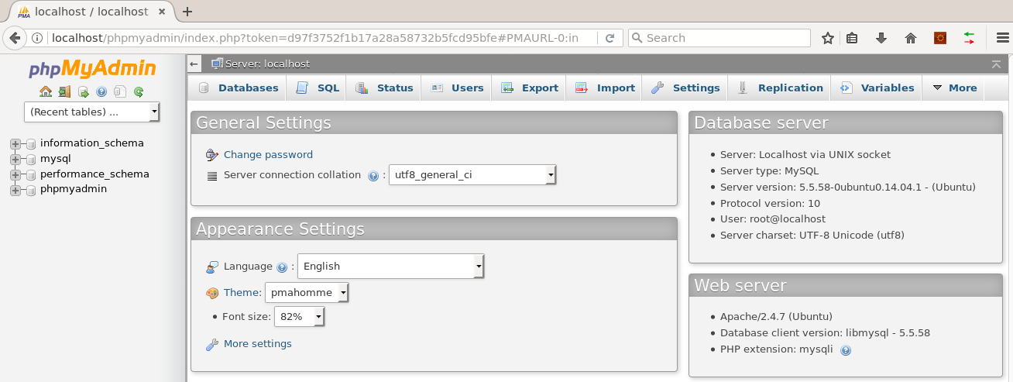
For accessing remote mysql server using local phpmyadmin
try to configure my PHPMyAdmin to access remote mysql server and it is really very easy to setup. Just you need to configure/modify a single in PHPMyAdmin folder i.e. “config.inc.php”.
Just add below lines to your “config.inc.php” file add the bottom:
$i++;
$cfg['Servers'][$i]['host'] = 'HostName:port'; //provide hostname and port if other than default
$cfg['Servers'][$i]['user'] = 'userName'; //user name for your remote server
$cfg['Servers'][$i]['password'] = 'Password'; //password
$cfg['Servers'][$i]['auth_type'] = 'config'; // keep it as config
If your mysql server is in remote than make sure that you are very much connected to box and than try to access PHPMyAdmin using url. You will get “Current Server:” drop down with both “127.0.0.1” and one what you have provided with “$cfg[‘Servers’][$i][‘host’]” cam switch between the servers.

Reference:
https://www.rosehosting.com/blog/install-phpmyadmin-on-ubuntu-16-04/
http://sforsuresh.in/access-remote-mysql-server-using-local-phpmyadmin/

